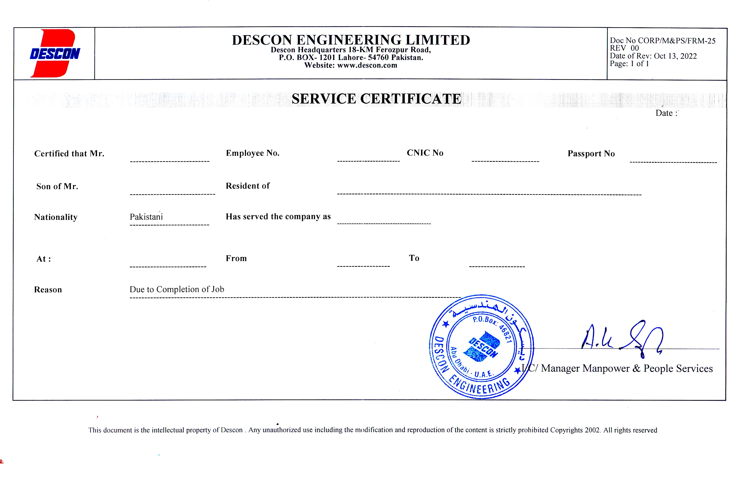

<To2>

<Name> 40052085 <CNIC> <Passport>

<fname> PAK

Work Permit Receiver

TAKREER PLANT <From2> <To2>